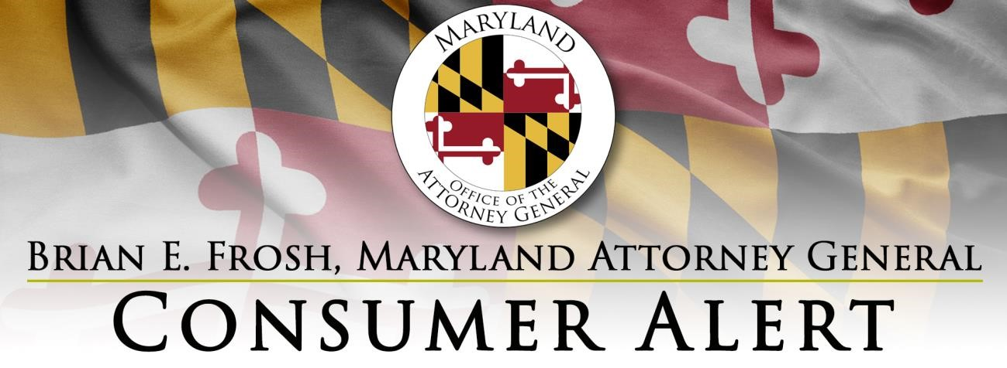

Consumer Alert – Maryland’s Moratorium on Residential Evictions
Set to Expire August 15, 2021

The Governor of Maryland’s Executive Order prohibiting residential evictions for non-payment of rent will expire on August 15, 2021. At that time, Maryland courts will be able to order evictions in cases filed since the temporary prohibition was ordered in March 2020, even if the residential tenant has suffered a significant loss of income due to the COVID pandemic. Eviction is a legal procedure. A landlord cannot just tell tenants they must move, change the locks, cut off the utilities, or put belongings out on the street. A landlord can file a failure to pay rent action in court as soon as the rent due date has passed and the tenant has not paid all of the rent. Currently, the landlord does not have to give advance notice of unpaid rent to the tenant before filing a failure to pay rent eviction. For more information about residential evictions in Maryland, including the CDC eviction moratorium that expires July 31, 2021, visit https://bit.ly/3foQbJU.
Tenants who are currently behind on their rent may qualify for rental assistance and may be able to obtain
legal help once a failure to pay rent action is filed. The Office of the Attorney General is providing this list of resources for tenants in need of assistance. Tenants should seek help as soon as possible.
Rental Assistance
- Maryland Emergency Rental Assistance Call Center: 877-546-5595 or dhcd.maryland.gov/Pages/EvictionPrevention/default.aspx (This site also has links to local/county rental assistance programs.)
- 2-1-1 Maryland: Call 2-1-1 and the staff will connect you with rental assistance (also available online at search.211md.org).
- Contact your local or county government to ask if it has a rental assistance program.

Legal Help
- Maryland Legal Aid (free and low-cost legal help): www.mdlab.org
- Disability Rights Maryland (free and low-cost legal help): 410-727-6352 or disabilityrightsmd.org
- (In Baltimore City) Public Justice Center (free and low-cost legal help): 410-625-9409 or publicjustice.org
- (In Baltimore City) Pro Bono Resource Center of Maryland (advice and same-day representation in rent court): 443-703-3053 or www.probonomd.org
- Community Legal Services of Prince George's County: 240-391-6370 or https://www.clspgc.org/
- Mid-Shore Pro Bono: 410-690-8128 or https://midshoreprobono.org/
- The People’s Law Library of Maryland (free and low-cost legal directory): www.peopleslaw.org/directory

More legal assistance resources may be found on The Maryland Legal Services Corporation website: www.mlsc.org/news-resources/find-legal-help/.

For help in resolving other landlord-tenant issues, please see our guide at https://bit.ly/3zwkshZ
(en español: https://bit.ly/3xpbpgW), or contact our Consumer Protection Division at consumer@oag.state.md.us or 410-528-8662.

